Quentin Nash

SWOT Analysis
For
Legacy Music Co.

SWOT Analysis
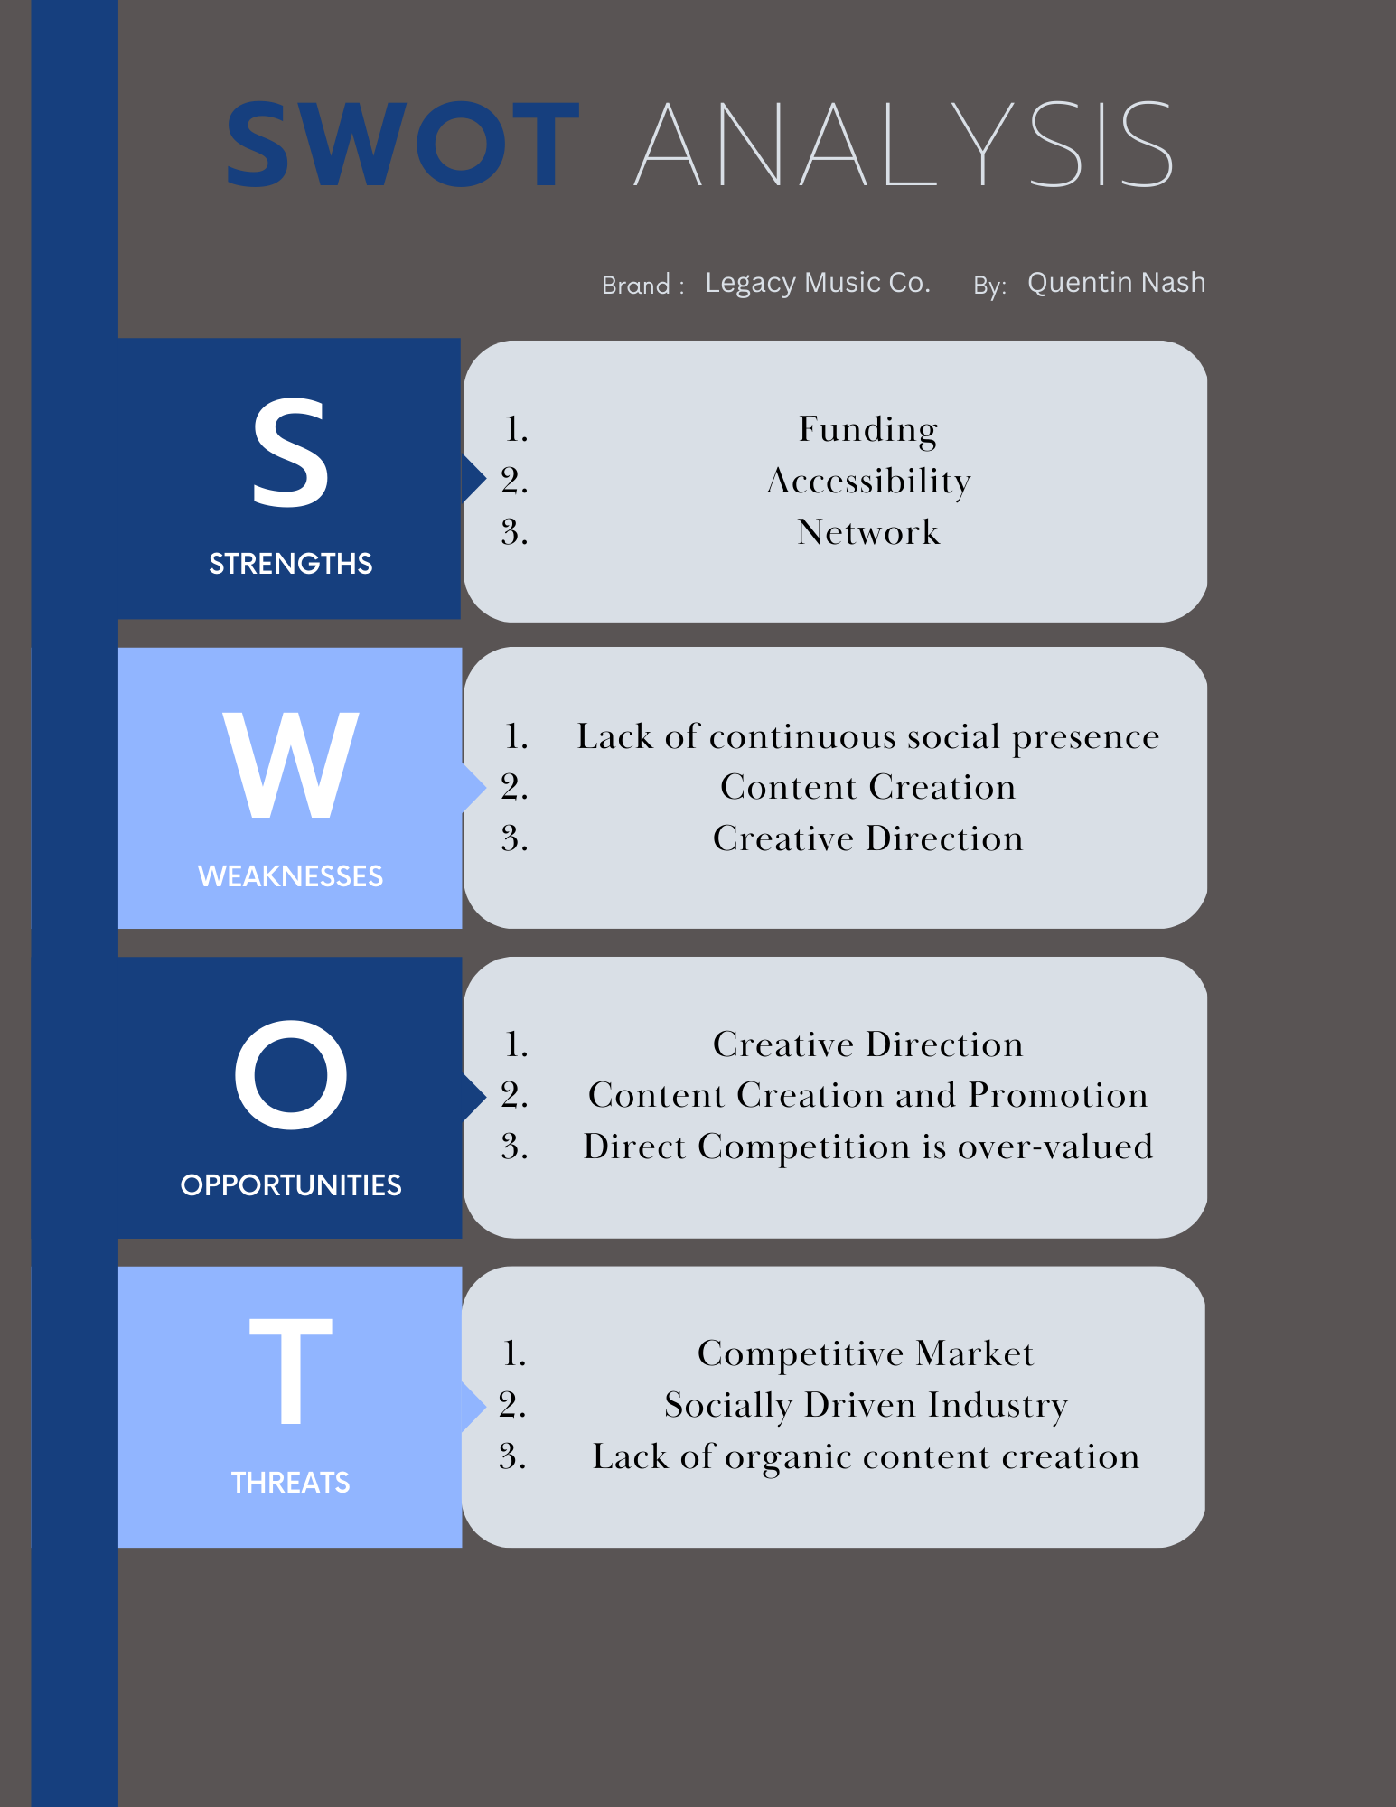
STRENGTHS - Legacy Music Co. has a great chance of being a successful multimedia powerhouse because it is the only one of its kind in the Charlotte Metro area. Utilizing LMC’s already established target market, it will be easy to persuade them to help build the organic following. Promoting that Legacy Music Co. is a grass roots company that represents its hometown proudly, is what gives LMC an edge. The hub prides itself on services not being sourced. LMC is centrally located and easily accessible, even by public transportation. Additionally, Nature has an amazing network that he has developed and has great funding.
WEAKNESSES - The weaknesses presented in the infographic are vital for any company operating in the entertainment and music industry. Although LMC does have social profiles and keeps up with minimal posting, there is no cohesive formatting. The social platforms that LMC uses consists only of brand and event promotion, making them very linear and not appealing to the trend-loving audience they cater to. Having a repetitive social media profile is the breeding grounds for getting lost in algorithms. Visibility is a driving factor in a company’s success, especially with META apps.
OPPORTUNITIES - This would be a great opportunity to implement a subtle, yet cohesive aesthetic, with content between the home site, legacymusic.co, and the social platforms used. Taking an approach to update formatting to the industry standard will help boost brand visibility. Utilizing proper promotional tools such as Google Ads to help raise the company’s awareness would be easily integrated since LMC doesn’t already use them, and they have a budget for promotion. Organic content creation is a key factor in this campaign and there is currently no direction or creation happening, allowing for easy application.
THREATS – Legacy Music Co. faces the threat of getting lost behind everyone else constantly posting more relevant material to their social medias. There is an algorithm that is very active amongst the top social media platforms, and not making it work for your company’s benefit is detrimental to success. There are two other well-known music recording studios in the Charlotte, NC. One is notorious for exaggerated pricing, less than great customer service, and almost never having sessions available for booking unless it’s six months to a year out. The other is known for fair pricing, but also is known for having a bad location and poor quality with their services. Although, these companies may indeed bear those traits, they are the most visible and active in the local market. They are the biggest threat initially for Legacy Music Co. because they’re both already established with clientele, and they have bigger social presences.

