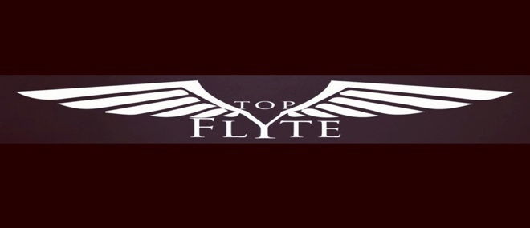

FOR IMMEDIATE RELEASE Contact: Quentin Nash | TFE, LLC
Phone: 704-303-2834
Email: topflyteentertainment@gmail.com

FOR THE STUDENTS INFORMATIONAL
Presented by Legacy Music Co.

Due to the success of “For the Culture”, For the Students will be held at The Underground in Charlotte’s Music Factory, right next the Fillmore. Not only were the kids amazed at the first event, but the parents were wowed too. As Creative Director of LMC, I originally suggested to have two separate weekends for the For the Culture event because of the appeal of mainstream media and entertainment to our younger generation. Within 10 days of opening ticket sales, we had to break down For the Culture into 2 days because over 400 tickets were sold! This webinar is an informational session that will delve deeper into what can be expected of the afterschool and collegiate extracurricular programs that are being offered by LMC. Please click here to RSVP. You don’t want to miss this.

July 1st, 2023, between 1:00-3:00 PM EST, Legacy Music Co. and Top Flyte Entertainment will be hosting an online webinar deemed “For the Students: Informational” to promote the second installment in its, “For the Culture” event series, “For the Students”. Gearing up for the 2023-2024 school year, LMC has vested interest in empowering our youth and giving them real world experiences and opportunities. From engineering to performing, to maintenance and design, For the Students will give the youth an opportunity to sharpen their skillset and add additional skills to their repertoire. Please join us for this informational if you have any questions, comments, or concerns, and check out what’s been going on lately at Legacy Music and Top Flyte Entertainment.

LMC and TFE takes the next step to continue “pushing the narrative in the music and entertainment industry.” Nathaniel “Nature” Jones is overwhelmed by the amount of love and support that continues to make waves for the Legacy | Builders division of LMC.

###
Legacy Music Co. and Top Flyte Entertainment, LLC

For more information please visit
legacymusic.co, tfeent.com, or email topflyteentertainment@gmail.com

